West Virginia FFA Parliamentary Procedure LDE Rules

Regional Contests:
  - Adopt the National Scorecard minus the "Minutes and Other Records Practicum" and the "Team Problem Solving Research"
  - Contest Points will total 800 (1000 points minus 50 points from Minutes Practicum and minus 150 points from Team Problem Solving Research)
  - Regional Test- 50 multiple choice questions worth 4 pts each (200 pts)
    - Narrow regional test to specific test each year on a rotational basis
    - Use the existing test bank of Shane Dunbar's Multiple-Choice Tests
      - Questions will be randomized from the test bank.
      - Example
        - Odd State Convention year – Tests 1 – 15
        - Even State Convention year – Tests 16 – 30
State Contest
  - Preliminary Round
    - Adopt the National Scorecard minus the "Minutes and Other Records Practicum" and the "Team Problem Solving Research"
    - Contest Points will total 800 (1000 points minus 50 points from Minutes Practicum and minus 150 points from Team Problem Solving Research)
    - National Test Setup (45 multiple choice and 5 research all worth 4 pts each (200 pts)
  - Finals Round
    - Adopt National Scorecard minus the section "Minutes and Other Records Practicum"
    - Contest Points will total 950 (1000points minus 50 points from Minutes Practicum)
    - Team Problem Solving Research Practicum only for teams making the Finals
      - Problem Solving activity will follow the same format as National Contest

Tests:
- Regional
  - Odd State Convention year – Tests 1 – 15
  - Even State Convention year – Tests 16 – 30
- State
  - National Format – Qualifying Test to become an Accredited Parliamentarian with the Society of Agriculture Education Parliamentarians
    - 45 multiple choice questions
    - 5 research questions using the latest edition of Roberts Rules of Order

Oral Questions:
- Regional
  - Dunbar’s Parliamentary Procedure Oral Questions – Challenge
    - Level One and Two Star
- State
  - Dunbar’s Parliamentary Procedure Oral Questions – Challenge
    - Level Two and Three Star

Example Motion Card:
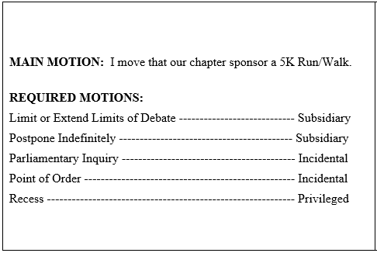

Team Activity:
- Regional
  - Not done
- State
  - Conducted only in finals
    - Format like National FFA Event

References:
- Roberts Rules of Order Newly Revised – Most current edition (12th edition)
- National FFA - Parliamentary Procedure - National FFA Organization
- The New Parliamentary Procedure Instructional Materials Center (dunbarparlipro.com)
  - Test - Dunbar's Manual of Parliamentary Procedure Test Questions #2 | Dunbar's Parli Pro (dunbarparlipro.com)
  - Oral Questions - Oral Questions - Basic & Challenge | Dunbar's Parli Pro (dunbarparlipro.com)
  - Other reference on Dunbar’s site are very useful for a beginning team to use to train.

